top25 <-Projectdata[Projectdata$Individuals_Affected >= 185000,]

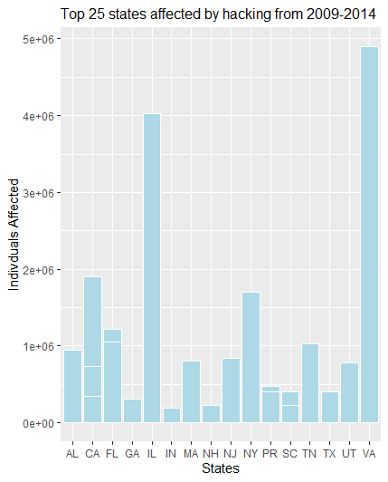ggplot(top25, aes(x=top25$State,y=top25$Individuals_Affected)) + geom_bar(stat = "identity",fill="lightblue",colour ="white",position = "dodge") + xlab("States") + ylab("Indivduals Affected") + ggtitle("Top 25 states affected by hacking from 2009-2014") + theme(plot.title = element_text(size = 12))

Projectdata$Type_of_Breach[Projectdata$Type_of_Breach == "Loss, Unauthorized Access/Disclosure"] <- "Loss"

Projectdata$Type_of_Breach[Projectdata$Type_of_Breach == "Loss, Improper Disposal"] <- "Loss

Projectdata$Type_of_Breach[Projectdata$Type_of_Breach %in% c("Theft, Hacking/IT Incident","Theft, Improper Disposal, Unauthorized Access/Disclosure","Theft, Loss","Theft, Loss, Improper Disposal","Theft, Loss, Other","Theft, Loss, Unauthorized Access/Disclosure, Unknown","Theft, Other","Theft, Unauthorized Access/Disclosure","Theft, Unauthorized Access/Disclosure, Hacking/IT Incident"," Theft, Unauthorized Access/Disclosure, Other")] <- "Theft"

Projectdata$Type_of_Breach[Projectdata$Type_of_Breach == "Theft, Unauthorized Access/Disclosure, Other"] <- "Theft"

Projectdata$Type_of_Breach[Projectdata$Type_of_Breach %in% c("Unauthorized Access/Disclosure, Hacking/IT Incident","Unauthorized Access/Disclosure, Hacking/IT Incident, Other","Unauthorized Access/Disclosure, Other")] <- "Unauthorized Access/Disclosure"

Projectdata$Type_of_Breach[Projectdata$Type_of_Breach == "Unknown, Other"] <- "Unknown"

Projectdata$Type_of_Breach[Projectdata$Type_of_Breach == "Hacking/IT Incident, Other"] <- "Hacking/IT Incident"

"Improper Disposal, Unauthorized Access/Disclosure"] <- "Improper Disposal"

summary(Projectdata$Type_of_Breach)

Hacking/IT Incident

76

Improper Disposal

39

Loss

98

Other

91

Theft

571

Unauthorized Access/Disclosure

168

Unknown

12